Stress PFE Counterparty Tearsheet
End-to-End Build Notes
Business context, the data, and the Strategy One implementation — with worked examples and diagrams.
How to read this. Written for two readers at once — the business reader (what counterparty credit risk, limits, and stress PFE are, and why they matter) and the technical reader (how the dashboard was built). Every technical choice is tied back to its business reason, and each concept is illustrated with an example. A running example threads through: the counterparty AGNC Investment Corp., whose line is CP_(TDBK)_(AMCQ_C2C) (TD Bank facing AGNC, counterparty code AMCQ).

Contents
1. The Business Problem
2. The Core Concepts (with examples)
3. The Data Landscape
4. The asts Table in Detail
5. Data-Quality Realities We Found
6. The Semantic Model
7. The Dashboard / Tearsheet
8. The Views — Logic and Construction
9. Parked Items and Notes for the Rebuild Team
10. Glossary

1. The Business Problem

What we are building
We are rebuilding a legacy per-counterparty PFE Stress Testing tearsheet — historically a static report from the SCREAM risk engine, assembled in Word/Excel — as a live, governed dashboard in Strategy One, sitting on a Mosaic semantic model over Databricks. A tearsheet is a one-page summary for a single counterparty: who they are, how much potential exposure TD has to them, how that exposure behaves under stress, where it breaches limits, and space for the analyst's commentary.
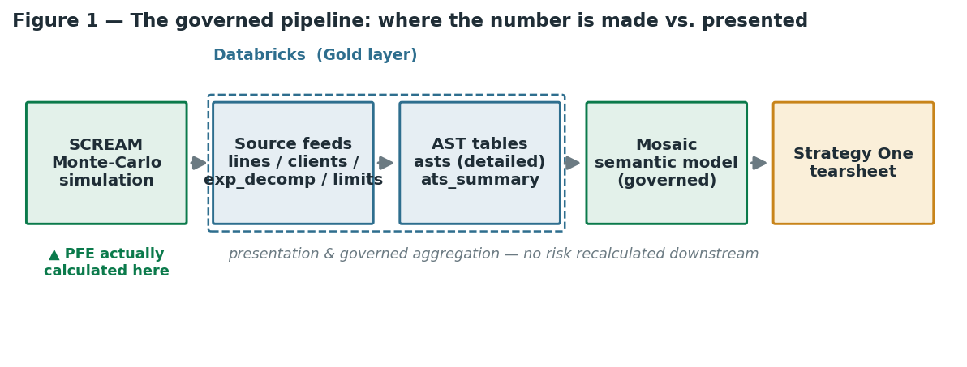
Figure 1 — The governed pipeline: where the number is made vs. where it is presented.

Why it matters — the business drivers
- Counterparty credit risk is a real loss channel. When TD trades derivatives or financing with a counterparty, TD can end up being owed money. If the counterparty defaults while owing TD, TD takes a loss. Credit Risk measures and limits that exposure before it becomes a loss.
- Stress testing reveals the tail. Normal-market exposure can look modest, but a 2008-style shock can multiply it. The business needs to see how bad it could get, not just today's number.
- Limits are how the bank controls appetite. Each line has limits; a breach (exposure over limit) is a signal requiring attention, escalation, or action.
- Governance. The legacy report lived in spreadsheets — ungoverned calculations that can't be audited. The thesis: any calculation outside the registered semantic model is ungoverned. Moving the logic into Databricks → Mosaic → Strategy makes the numbers governed, versioned, and self-service.
Who reads it: a credit-risk analyst reviewing a counterparty, deciding whether a stressed breach needs action, and recording why.

2. The Core Concepts (with examples)
This section is the heart of the business understanding — read it even if you skip the rest.

2.1 Counterparty Credit Risk (CCR)
Plain version: the risk that someone TD trades with fails to pay what they owe.
Real-life analogy: lending a friend money is credit risk. CCR is subtler — it is like co-signing a deal whose value swings: you might be owed money one month and owe money the next. You only lose if (a) they owe you and (b) they default at that moment.
Example: TD enters a 5-year interest-rate swap with AGNC. At inception it is worth about $0 to both sides. Six months later, rates have moved and the swap is worth +$10M to TD (AGNC owes TD $10M). If AGNC defaults right then, TD loses that $10M — that is TD's exposure at that moment.

2.2 Potential Future Exposure (PFE) — the key metric
Exposure today is knowable; exposure in the future is not — it depends on where the market goes. PFE is a simulated estimate of how large the exposure could plausibly become over the life of the trades. The SCREAM engine runs a Monte Carlo simulation (thousands of future market paths), revalues TD's positions on each, and takes a high percentile of the exposure distribution.
Real-life analogy: a weather forecast does not say 'it will rain 4mm'; it says 'the 90th-percentile rainfall could be 30mm'. PFE is the high percentile of future exposure, not the average.
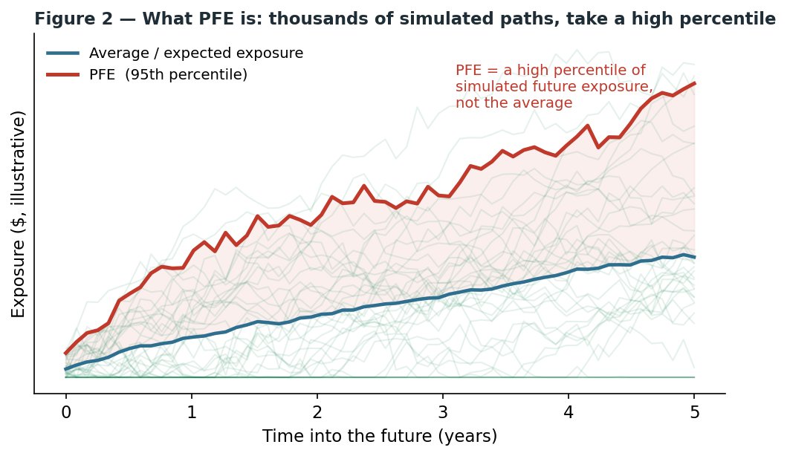
Figure 2 — What PFE is: thousands of simulated paths, then take a high percentile.

2.3 Tenor / Time Buckets — exposure has a maturity profile
Exposure is not a single number; it changes over the life of the trades. So PFE is measured across time buckets: 0–3 Mo, 3–12 Mo, 1–2 Yr, 2–5 Yr, 5–10 Yr, 10–50 Yr.
Example (AGNC): potential exposure is small in 0–3 Mo but balloons in the 2–5 Yr bucket — exactly where its largest breach sits.
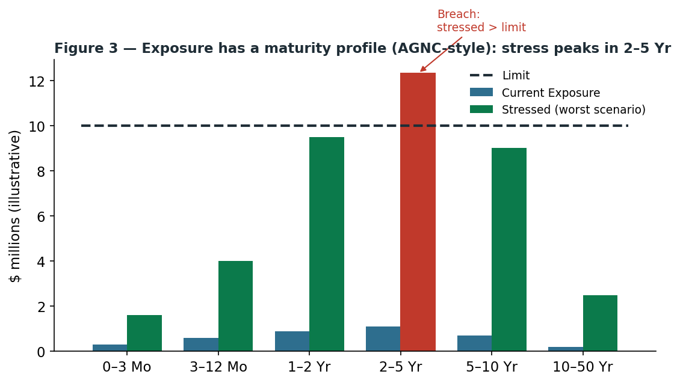
Figure 3 — Exposure across the maturity curve: stress peaks (and breaches the limit) in 2–5 Yr.

2.4 Max Usage and Limits — utilization
Limit: the maximum exposure TD is willing to carry on a line, set per tenor bucket; it encodes credit appetite. Max Usage: the peak PFE within a bucket under a scenario — how much of the limit the exposure consumes.
Real-life analogy: a credit card. The limit is your credit line; usage is what you have charged. Go over the limit and you have a breach. Example: if AGNC's 2–5 Yr limit is $10M and stressed Max Usage is $12.3M, the line is over limit in that bucket.

2.5 Current vs Stressed Exposure
Standard / Current Exposure is PFE under normal market assumptions (the unstressed base). Stressed Exposure is PFE after re-running the simulation under a stress scenario. Example (AGNC, 2–5 Yr): Current ≈ $296,801; Stressed ≈ $12,278,413 — roughly 40× larger. That gap is the whole point of stress testing.

2.6 Stress Scenarios — why correlation and volatility
Stress scenarios re-run the simulation with stressed correlations and volatilities; the most punishing crank correlation toward 1.0.
Why correlation matters (analogy): a diversified portfolio is safe because its holdings do not all move together. In a crash (2008, March 2020), 'all correlations go to 1': everything falls together, diversification evaporates, exposure spikes. Stress scenarios deliberately simulate that. This is why Correlation_1.0 is often the binding scenario — it removes all diversification benefit.
Engine code | Summary shorthand | Descriptive name (tearsheet legend)*
BASE | Cartor / Base | Base (≈ Current Exposure)
ZeroCorrelation | Zero | Volatility & Correlation-0
Correlation_0.25 | 25 | Volatility & Intermediate-Market-0 Correlation*
Correlation_0.75 | 75 | Volatility & Intermediate-Market-1 Correlation*
Correlation_1.0 | One | Volatility & Correlation-1
STRMARKETC75 | STR75 | STRMARKETC75
ProdCorrelation | Prod | Volatility & Market Correlation*
STRMPR025 | STRMPR025 | STRMPR025
* Starred descriptive names are a blueprint placeholder read off the sample legend and not yet validated — see §8.3 and §9.

2.7 Breach — and why it is not just 'over the limit'
A breach is not simply Max Usage > Limit. The business rule (pre-computed in our data) requires both: (1) Max Usage > Limit × (Excess% + 1), and (2) Max Usage > Limit + a rating-based buffer. The Excess% and buffer come from the Credit Limit Threshold table, keyed on the worst rating (leading number only — e.g. '4A' → 4).
Worst Rating | Limit | Excess %
0 | 300M | 50%
1 | 300M | 50%
2 | 100M | 40%
3 | 50M | 30%
4 or worse | 10M | 30%

Worked example (AGNC, rating 4A → 4): limit band $10M, excess 30%. A bucket breaches only if stressed Max Usage exceeds $10M × 1.30 = $13M and exceeds $10M + buffer. The two-part test stops trivial overshoots from being flagged — the business only wants material breaches escalated.
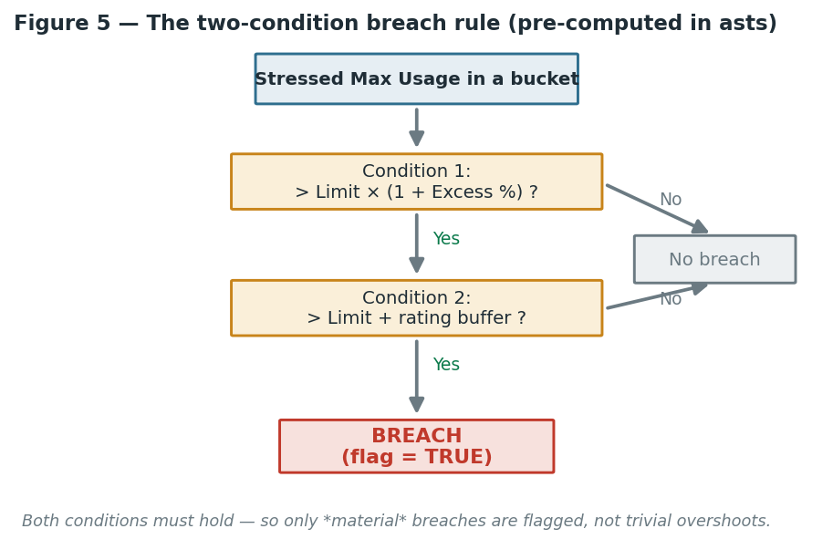
Figure 5 — The two-condition breach rule (already computed in asts).

2.8 Gross vs Net, Netting, and Collateral (CSA)
- Gross exposure: the sum of what TD is owed, ignoring offsets — worst case before mitigation.
- Netting (ISDA): TD's many trades with one counterparty offset. Example: +$20M and −$15M net to $5M, not $20M.
- Collateral / CSA: an agreement to post collateral as exposure grows. CSA Direction (e.g. 2-Way) = both sides post. CP Threshold = how far the counterparty's owing can grow before they post collateral to TD (e.g. CP threshold $5M caps TD's uncollateralized exposure near $5M). TD Threshold is the mirror. MTA = minimum transfer amount, so collateral only moves in meaningful chunks.
Why it matters: netting and collateral are the main reasons real exposure is far below gross. The tearsheet's CSA section (annotation #2) tells the analyst what mitigation is in place.

2.9 TD Sub and OTC/SFT
TD Sub: some lines face TD's own entities (e.g. TD Securities (USA) LLC) — TD lending to itself, not external credit risk — so they are flagged TD Sub = Y and carved out of external breach reporting (like moving money between your own accounts). OTC vs SFT: over-the-counter derivatives vs Securities Financing Transactions (repo / sec lending); codes containing _DBL/_EBL/_BSB → SFT, else OTC.

3. The Data Landscape
Where exposure is actually calculated: the SCREAM engine (the Monte-Carlo simulator). Everything downstream — the AST tables, our views, Strategy — is business aggregation and presentation, not risk re-calculation. That separation is the backbone of governance: the risk number has one authoritative source (see Figure 1).

3.1 The source feeds (schema xvala_core-raw)
Feed | Role | What it is, in business terms
lines_report.csv | Fact | Published exposure-vs-limit at line grain: Max Usage ×6, Limit ×6, Gross Max Exposure, worst rating.
clients_report.csv | Dimension | Counterparty reference: code, name, ratings, country, industry, and the netting/CSA agreement block (ISDA/CSA flags, Agreement ID).
exp_decomp_report.csv | Lineage | Tall reconciliation that ties decomposed exposure back to lines_report (a Difference row = 0 proves the tie).
Line_Exclusion_Table.csv | Exclusions | Approval-workflow list removing internal test lines.
limits.csv | Reference | The live Credit Limit Threshold table (rating → limit, excess %).

3.2 The AST output tables (schema xvala_xva)
The AST process consumes the SCREAM feeds and produces two tables the tearsheet is built on: asts — the detailed table, grain ≈ line × scenario, six time buckets laid out wide (one column per bucket); and ats_summary — one row per line, carrying the per-scenario maxima, Max of All, Scenario of Max, Percentage of Impact, and enrichment. The summary answers 'what is the worst across everything for this line'; the detailed table holds the full bucket × scenario grid needed for the maturity charts.

4. The asts Table in Detail
54 columns, grouped by family:
- Identity / line: Scenario_Name, Line, Long_Name, Line_Type, Line_Expiry (int, YYYYMMDD — e.g. 20180531 = 2018-05-31), No_Line_Indicator, Line_Currency, Worst_Rating_Of_Associated_Clients.
- Current usage — 6 wide buckets: Standard_Usage_0_3_mo … Standard_Usage_10_50_Yr.
- Stressed max usage — 6 wide buckets: Max_Usage_0_3_mo … Max_Usage_10_50_Yr (per-scenario stressed PFE).
- Limits — 6 wide buckets, named by tenor ENDPOINT: Limit_3_mo, Limit_1_Yr, Limit_2_Yr, Limit_5_Yr, Limit_10_Yr, Limit_50_Yr.
- Breach flags — 6 wide (TRUE/FALSE strings): 0_3_mo_Excess_Breach … 10_50_Yr_Excess_Breach (already encode the two-condition rule).
- Excess % — 6 wide (double): 0_3_mo_Excess_Percentage … 10_50_Yr_Excess_Percentage.
- Line-level summary: Gross_Max_Exposure, Max_Scenario_Exposure, Max_Exp_Time_Bucket, Max_Scenario_Name, Standard_Exposure, Excess_Percentage, Exposure_Percentage (+ per-bucket), business_date.
- Lineage leftovers: Scenario, Timestep (from an exp_decomp-style merge; a likely source of duplicate-looking rows).
Trap 1 — Limit naming. Usage columns are named by range (_0_3_mo …) but limits by their endpoint, so they map positionally: Limit_3_mo → 0–3 Mo, Limit_1_Yr → 3–12 Mo, Limit_2_Yr → 1–2 Yr, Limit_5_Yr → 2–5 Yr, Limit_10_Yr → 5–10 Yr, Limit_50_Yr → 10–50 Yr. Get this wrong and the limit line sits against the wrong buckets.

Trap 2 — String dollars. Every dollar/usage/limit column is typed string (only Excess_Percentage is double). Anything that plots them must cast: TRY_CAST(REPLACE(col, ',', '') AS DOUBLE).

5. Data-Quality Realities We Found
Real wrinkles in asts we discovered and worked around, flagged for the rebuild team to fix at source:
- 35 exact-duplicate rows — removed in every view with SELECT DISTINCT * (the asts0 CTE).
- Long_Name has variants per line (stray spaces/truncation). Including it in a GROUP BY split a line in two → doubled Limit/Current (12 rows not 6). Fix: group on (Line, business_date) only, pull Long_Name via MAX().
- The BASE row can have null Limit/Usage. Our first dedup picked the alphabetically-first scenario (BASE), whose limits were null → empty Limit. Fix: MAX() across the line's rows (MAX ignores nulls; limits are constant per line).
- Line_Type appeared multi-valued for some lines — investigated; tied to duplicate/lineage rows, not a true composite key.
- All-string dollars and Line_Expiry as YYYYMMDD int — handled with casts.
We proceeded anyway: these are blueprint-acceptable. The summary rebuild is another team's process; our job was to prove the end-to-end tearsheet on current data, with wrinkles documented.

6. The Semantic Model
The model (Mosaic, 'Stress PFE Data Model') is where raw Databricks columns become governed business objects — Borrower, Line, Worst Rating, Time Bucket, Scenario, Limit, Excess %. Defining them once, centrally, means every chart and analyst uses the same definition — the opposite of everyone rolling their own spreadsheet formula.
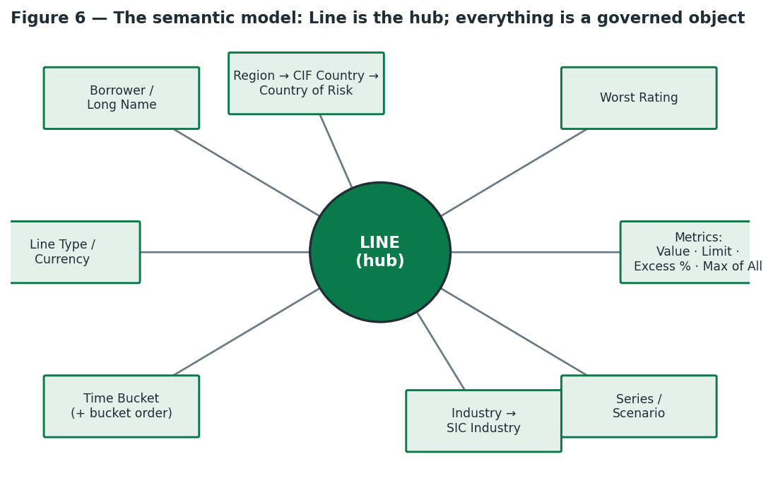
Figure 6 — The semantic model: Line is the hub; dimensions, hierarchies, and metrics hang off it.
What is in it: ~29 attributes, ~52 metrics; Line is the central hub; hierarchies for drill (Region → CIF Country Name → Country Of Risk, and Industry → SIC Industry); breach indicators kept as attributes (text TRUE/FALSE) because their job is filtering, not arithmetic.

Aggregation rules — tied to business meaning
- Dollars → Sum when rolling up across lines (a portfolio total is the sum of line exposures); within a line the bucket max is already baked in.
- Ratios / percentages → Max, never Sum. Why: summing percentages is meaningless — two lines at 80% and 90% utilization are not 170%. So Excess % and Exposure % use MAX.

Renaming and the Time Bucket sort
Raw engine columns (Cartor Maximum, STR MPR 025 Maximum) were relabeled to friendly names (Base, 0.25, STR75, Prod, …) so analysts read scenarios, not engine codes. Time Bucket initially sorted alphabetically (0-3 Mo, 1-2 Yr, 10-50 Yr, 2-5 Yr…). Fix: the view emits a numeric bucket_order (1–6); we added it as a form of the Time Bucket attribute and set the attribute's sort to Bucket Order ascending. Key lesson: the sort must live on the attribute on the axis — sorting a separate Bucket Order attribute does nothing.

7. The Dashboard / Tearsheet
Dashboard: 'Stress PFE | Chapter 1 | Page 1'. Each visual is paired with the business question it answers.
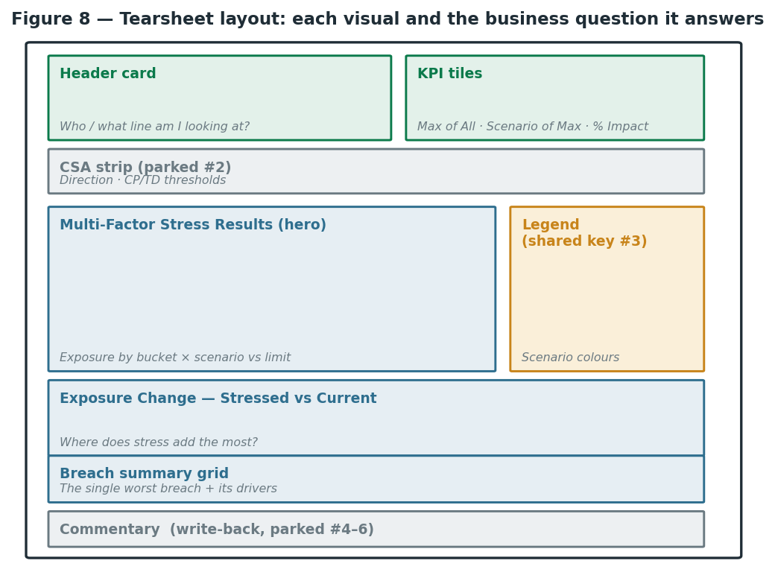
Figure 8 — Tearsheet layout: each visual and the business question it answers.
- Header card — Who and what am I looking at? Borrower, Line, Rating, Exposure Type, Currency; transposed into a vertical card. Note: the dashboard is per-line, not per-borrower (AGNC has three lines), so cascading Borrower ↔ Line filters let the analyst drill in.
- Scenario-maxima bars (Viz 1) — Which stress scenario is worst? Eight scenario-max metrics as bars; the tallest is binding. (Because each bar is a separate metric, Strategy can't auto-sort/highlight — fine for a single-line tearsheet.)
- KPI tile — The headline. Max of All, Scenario of Max, Percentage of Impact. Example: Percentage of Impact 1,489% means the stressed peak is ~15× the base (~$1.1M → ~$16.4M).
- Multi-Factor Stress Results (Viz 3, the hero) — How does exposure behave across the maturity curve, per scenario, vs the limit? x = Time Bucket, y = Value, colour = Series. Required the wide→long unpivot (§8.1).
- Exposure Change, Stressed vs Current — Where does stress add the most? One line per scenario of (stressed − current) across buckets.
- Breach summary grid — What is the single worst breach and what drives it? From vw_asts_largest_breach (§8.2). Beneath sits the commentary block (manual, §8.4).
- Shared legend (annotation #3) — the auto-generated chart legend is the scenario colour key; to present it as a separate box, lock Series colours page-wide first, then position one legend to the side.

8. The Views — Logic and Construction
The hard work lived in SQL views over asts. Recurring principle: do the data shaping in governed views so the dashboard stays simple and single-table — which also avoids Cartesian/fan-out joins.
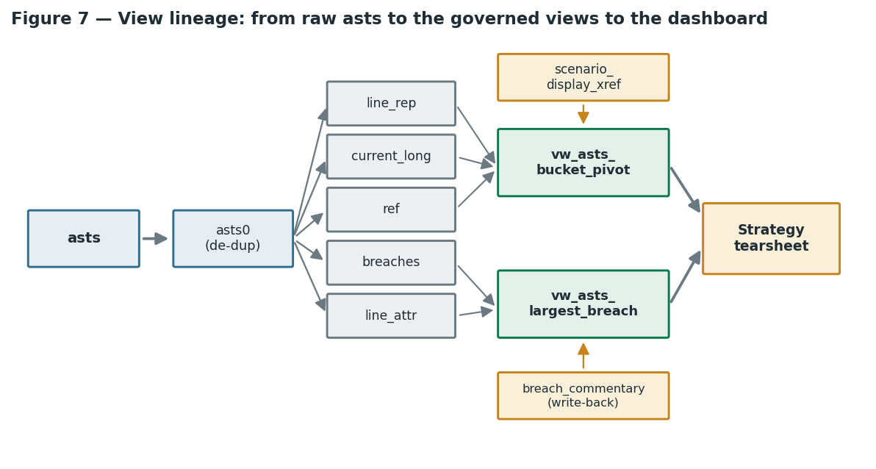
Figure 7 — View lineage: from raw asts through the CTEs and views to the dashboard.

8.1 vw_asts_bucket_pivot — wide → long, the engine of the charts
Business need: the hero and exposure-change charts need Time Bucket and Series as dimensions you can put on an axis / colour by. But asts stores buckets wide (one column per bucket) and has no single 'series' column — and you cannot put a column name on an axis. So we unpivot.
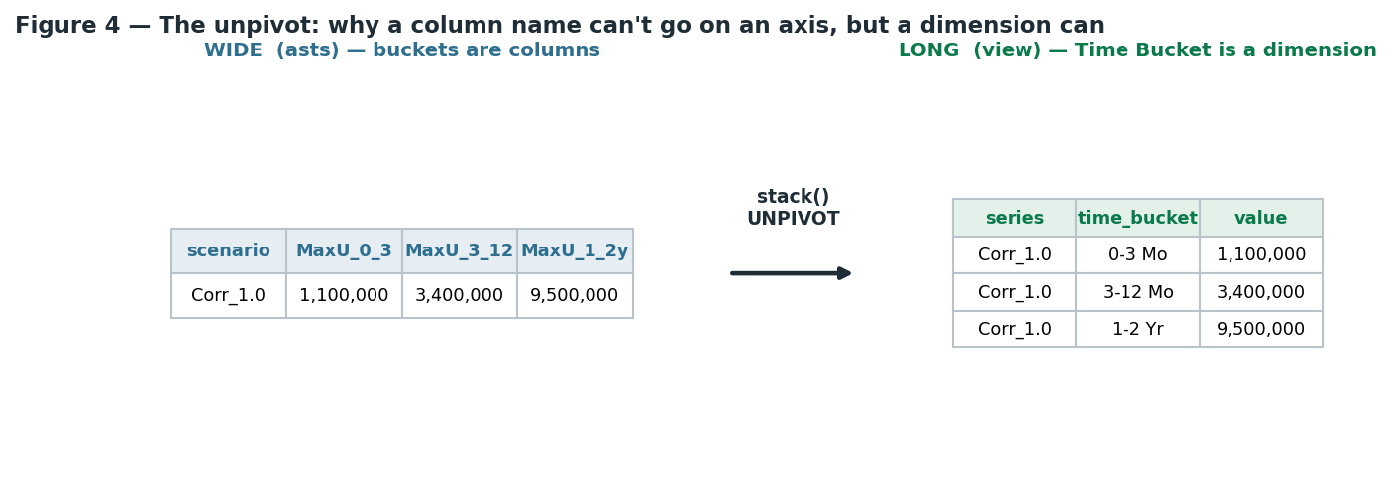
Figure 4 — The unpivot: a column name can't go on an axis, but a dimension can.
Construction, CTE by CTE: asts0 drops the 35 duplicates; line_rep makes one row per (Line, business_date) using MAX on every Limit/Standard column (de-dupes and grabs the non-null value, fixing the empty-BASE-row problem, and grouping on the true key avoids Long_Name doubling); current_long gives one current_value per (line, bucket) for the delta; base_long is three UNION ALL blocks (scenario usage, current exposure, limit — the limit using the positional map) via Spark stack(6, …); the final SELECT adds current_value + change_vs_current and translates scenario codes through scenario_display_xref, with everything cast and a bucket_order for sorting.
CREATE OR REPLACE VIEW `d4001-centralus-tdvip-creditrisk`.`xvala_xva`.`vw_asts_bucket_pivot` AS
WITH asts0 AS (
SELECT DISTINCT * FROM `d4001-centralus-tdvip-creditrisk`.`xvala_xva`.`asts`
),
line_rep AS (
SELECT Line, business_date, MAX(Long_Name) AS Long_Name,
MAX(Limit_3_mo) AS Limit_3_mo, MAX(Limit_1_Yr) AS Limit_1_Yr,
MAX(Limit_2_Yr) AS Limit_2_Yr, MAX(Limit_5_Yr) AS Limit_5_Yr,
MAX(Limit_10_Yr) AS Limit_10_Yr, MAX(Limit_50_Yr) AS Limit_50_Yr,
MAX(Standard_Usage_0_3_mo) AS Standard_Usage_0_3_mo,
MAX(Standard_Usage_3_12_mo) AS Standard_Usage_3_12_mo,
MAX(Standard_Usage_1_2_Yr) AS Standard_Usage_1_2_Yr,
MAX(Standard_Usage_2_5_Yr) AS Standard_Usage_2_5_Yr,
MAX(Standard_Usage_5_10_Yr) AS Standard_Usage_5_10_Yr,
MAX(Standard_Usage_10_50_Yr) AS Standard_Usage_10_50_Yr
FROM asts0 GROUP BY Line, business_date
),
current_long AS (
SELECT line, business_date, bucket_order,
TRY_CAST(REPLACE(value_str, ',', '') AS DOUBLE) AS current_value
FROM (
SELECT Line AS line, business_date,
stack(6, 1,Standard_Usage_0_3_mo, 2,Standard_Usage_3_12_mo, 3,Standard_Usage_1_2_Yr,
4,Standard_Usage_2_5_Yr, 5,Standard_Usage_5_10_Yr, 6,Standard_Usage_10_50_Yr
) AS (bucket_order, value_str)
FROM line_rep
)
),
base_long AS (
-- 1) stressed usage per scenario
SELECT line, long_name, business_date, scenario, series, time_bucket, bucket_order,
TRY_CAST(REPLACE(value_str, ',', '') AS DOUBLE) AS value
FROM (
SELECT Line AS line, Long_Name AS long_name, business_date,
Scenario_Name AS scenario, Scenario_Name AS series,
stack(6, '0-3 Mo',1,Max_Usage_0_3_mo, '3-12 Mo',2,Max_Usage_3_12_mo,
'1-2 Yr',3,Max_Usage_1_2_Yr, '2-5 Yr',4,Max_Usage_2_5_Yr,
'5-10 Yr',5,Max_Usage_5_10_Yr,'10-50 Yr',6,Max_Usage_10_50_Yr
) AS (time_bucket, bucket_order, value_str)
FROM asts0
)
UNION ALL -- 2) current exposure
SELECT line, long_name, business_date, CAST(NULL AS STRING), 'Current Exposure', time_bucket, bucket_order,
TRY_CAST(REPLACE(value_str, ',', '') AS DOUBLE)
FROM (
SELECT Line AS line, Long_Name AS long_name, business_date,
stack(6, '0-3 Mo',1,Standard_Usage_0_3_mo, '3-12 Mo',2,Standard_Usage_3_12_mo,
'1-2 Yr',3,Standard_Usage_1_2_Yr, '2-5 Yr',4,Standard_Usage_2_5_Yr,
'5-10 Yr',5,Standard_Usage_5_10_Yr,'10-50 Yr',6,Standard_Usage_10_50_Yr
) AS (time_bucket, bucket_order, value_str)
FROM line_rep
)
UNION ALL -- 3) limit (positional column -> bucket mapping)
SELECT line, long_name, business_date, CAST(NULL AS STRING), 'Limit', time_bucket, bucket_order,
TRY_CAST(REPLACE(value_str, ',', '') AS DOUBLE)
FROM (
SELECT Line AS line, Long_Name AS long_name, business_date,
stack(6, '0-3 Mo',1,Limit_3_mo, '3-12 Mo',2,Limit_1_Yr,
'1-2 Yr',3,Limit_2_Yr, '2-5 Yr',4,Limit_5_Yr,
'5-10 Yr',5,Limit_10_Yr,'10-50 Yr',6,Limit_50_Yr
) AS (time_bucket, bucket_order, value_str)
FROM line_rep
)
)
SELECT b.line, b.long_name, b.business_date, b.scenario,
COALESCE(x.display_name, b.series) AS series,
b.time_bucket, b.bucket_order, b.value,
c.current_value,
b.value - c.current_value AS change_vs_current
FROM base_long b
LEFT JOIN current_long c
ON b.line=c.line AND b.business_date=c.business_date AND b.bucket_order=c.bucket_order
LEFT JOIN `d4001-centralus-tdvip-creditrisk`.`xvala_xva`.`scenario_display_xref` x
ON b.series = x.scenario_code;

8.2 vw_asts_largest_breach — the breach summary, done properly
Business need: show the single worst breach for a line — which bucket, which scenario, how big. We use the pre-computed breach flags (which already encode the two-condition rule), keep only TRUE flags, and rank the breaching cells per line by excess amount (stressed − limit), taking the top. line_attr converts Line_Expiry (YYYYMMDD int) to a real date. The result is one row per line, single-table — so the grid reads everything from here.
Fan-out lesson. Pulling Line Expiry Date from a different (many-row-per-line) table caused a Cartesian product in the grid. The fix was to bring the expiry into this one-row-per-line view. Rule of thumb: a grid sourced from a 1-row-per-line view should pull every field from that view.

CREATE OR REPLACE VIEW `...`.`xvala_xva`.`vw_asts_largest_breach` AS
WITH asts0 AS ( SELECT DISTINCT * FROM `...`.`xvala_xva`.`asts` ),
ref AS (
SELECT line, business_date, bucket_order,
TRY_CAST(REPLACE(limit_str, ',','') AS DOUBLE) AS limit_value,
TRY_CAST(REPLACE(current_str,',','') AS DOUBLE) AS current_value
FROM (
SELECT Line AS line, business_date,
stack(6, 1,Limit_3_mo,Standard_Usage_0_3_mo, 2,Limit_1_Yr,Standard_Usage_3_12_mo,
3,Limit_2_Yr,Standard_Usage_1_2_Yr, 4,Limit_5_Yr,Standard_Usage_2_5_Yr,
5,Limit_10_Yr,Standard_Usage_5_10_Yr, 6,Limit_50_Yr,Standard_Usage_10_50_Yr
) AS (bucket_order, limit_str, current_str)
FROM ( SELECT Line, business_date,
MAX(Limit_3_mo) Limit_3_mo, MAX(Limit_1_Yr) Limit_1_Yr, MAX(Limit_2_Yr) Limit_2_Yr,
MAX(Limit_5_Yr) Limit_5_Yr, MAX(Limit_10_Yr) Limit_10_Yr, MAX(Limit_50_Yr) Limit_50_Yr,
MAX(Standard_Usage_0_3_mo) Standard_Usage_0_3_mo, MAX(Standard_Usage_3_12_mo) Standard_Usage_3_12_mo,
MAX(Standard_Usage_1_2_Yr) Standard_Usage_1_2_Yr, MAX(Standard_Usage_2_5_Yr) Standard_Usage_2_5_Yr,
MAX(Standard_Usage_5_10_Yr) Standard_Usage_5_10_Yr, MAX(Standard_Usage_10_50_Yr) Standard_Usage_10_50_Yr
FROM asts0 GROUP BY Line, business_date )
)
),
line_attr AS (
SELECT Line AS line, business_date,
to_date(CAST(MAX(Line_Expiry) AS STRING), 'yyyyMMdd') AS line_expiry
FROM asts0 GROUP BY Line, business_date
),
breaches AS (
SELECT line, business_date, scenario, time_bucket, bucket_order,
TRY_CAST(REPLACE(usage_str,',','') AS DOUBLE) AS stressed_exposure,
UPPER(TRIM(breach_str)) AS breach_flag, excess_pct
FROM (
SELECT Line AS line, business_date, Scenario_Name AS scenario,
stack(6,
'0-3 Mo',1,Max_Usage_0_3_mo, `0_3_mo_Excess_Breach`, `0_3_mo_Excess_Percentage`,
'3-12 Mo',2,Max_Usage_3_12_mo, `3_12_mo_Excess_Breach`, `3_12_mo_Excess_Percentage`,
'1-2 Yr',3,Max_Usage_1_2_Yr, `1_2_Yr_Excess_Breach`, `1_2_Yr_Excess_Percentage`,
'2-5 Yr',4,Max_Usage_2_5_Yr, `2_5_Yr_Excess_Breach`, `2_5_Yr_Excess_Percentage`,
'5-10 Yr',5,Max_Usage_5_10_Yr, `5_10_Yr_Excess_Breach`, `5_10_Yr_Excess_Percentage`,
'10-50 Yr',6,Max_Usage_10_50_Yr,`10_50_Yr_Excess_Breach`,`10_50_Yr_Excess_Percentage`
) AS (time_bucket, bucket_order, usage_str, breach_str, excess_pct)
FROM asts0
)
)
SELECT * FROM (
SELECT b.line, b.business_date,
b.scenario AS scenario_of_largest_breach,
b.time_bucket AS bucket_of_largest_breach,
b.stressed_exposure, r.limit_value AS limit, r.current_value AS current_exposure,
(b.stressed_exposure - r.limit_value) AS excess_amount, b.excess_pct, la.line_expiry,
ROW_NUMBER() OVER (PARTITION BY b.line, b.business_date
ORDER BY (b.stressed_exposure - r.limit_value) DESC) AS rn
FROM breaches b
JOIN ref r ON b.line=r.line AND b.business_date=r.business_date AND b.bucket_order=r.bucket_order
JOIN line_attr la ON b.line=la.line AND b.business_date=la.business_date
WHERE b.breach_flag = 'TRUE'
) WHERE rn = 1;

8.3 scenario_display_xref — the governed scenario-name map (blueprint)
Business need: the legend uses descriptive names, not engine codes. Putting the mapping in a reference view (not hardcoded in logic) means the team validates/updates one object when the authoritative scenario dictionary arrives — the governed way.
Blueprint / placeholder. Names were read off the sample legend and are not yet validated. Confident: ZeroCorrelation, Correlation_1.0. Guesses (confirm or swap): the 0.25/0.75 → Intermediate-Market labels and ProdCorrelation → 'Market Correlation'.

CREATE OR REPLACE VIEW `...`.`xvala_xva`.`scenario_display_xref` AS
SELECT * FROM VALUES
('BASE', 'Base'),
('ZeroCorrelation', 'Volatility & Correlation-0'), -- confident
('Correlation_1.0', 'Volatility & Correlation-1'), -- confident
('Correlation_0.25', 'Volatility & Intermediate-Market-0 Correlation'), -- GUESS
('Correlation_0.75', 'Volatility & Intermediate-Market-1 Correlation'), -- GUESS
('ProdCorrelation', 'Volatility & Market Correlation'), -- GUESS
('STRMARKETC75', 'STRMARKETC75'),
('STRMPR025', 'STRMPR025')
AS t(scenario_code, display_name);

8.4 breach_commentary — write-back table (blueprint)
Business need: the analyst's narrative (Primary/Secondary Risk Drivers, Products Driving Exposure, Notes) has no source feed — a human types it. Strategy's SQL Transaction Forms turn a dashboard grid into an editable form that writes back to this table; the breach grid then LEFT JOINs it (1:1 by line+date, no fan-out) to display the commentary. Edits should be permission-scoped and audited; confirm Transaction-Forms write-back is enabled for the Databricks SQL warehouse connection.
CREATE TABLE IF NOT EXISTS `...`.`xvala_xva`.`breach_commentary` (
line STRING, business_date STRING,
primary_risk_driver STRING, secondary_risk_driver STRING,
products_driving_exposure STRING, notes STRING,
updated_by STRING, updated_at TIMESTAMP
) USING DELTA;

9. Parked Items and Notes for the Rebuild Team
Data quality (fix at source in asts): 35 duplicate rows; Long_Name variants; null Limit on the BASE row; grain is line × scenario but not perfectly clean.
Dashboard polish: Limit as a line on the hero chart (needs a limit_value column + a derived Limit metric, since shape is set per-metric and Limit is currently a series element); colour-lock scenarios page-wide; validate the scenario display-name dictionary and finalize the standalone legend box.
External / manual feeds (annotations): #1 Lending Manager → IHMS; #2 CSA Direction + CP/TD Thresholds → clients_report agreement block and SCREAM netting_xref.csv / client_info_nova.csv (CSA is per counterparty, joined Line → Counterparty — the line name embeds the CP code, e.g. AMCQ); #4–6 Risk Drivers / Products / Notes → manual write-back via breach_commentary + Transaction Forms; #7 'Number' → a derived rank of breaches by stressed PFE.
Versioning: the views and model can be exported to YAML and stored in Git (Strategy's March 2026 capability) so the whole stack is version-controlled and auditable.

10. Glossary
Term | Meaning
CCR | Counterparty Credit Risk — risk a trading counterparty defaults while owing TD.
PFE | Potential Future Exposure — simulated high-percentile estimate of future exposure.
Max Usage | Peak PFE within a tenor bucket under a scenario; how much of the limit is used.
Limit | Max exposure TD will carry on a line, per tenor bucket; encodes credit appetite.
Breach | Max Usage over limit per the two-condition rule (excess % and rating buffer).
Current / Standard Exposure | PFE under normal (unstressed) market assumptions.
Stressed Exposure | PFE after re-simulating under a stress scenario.
Gross Max Exposure | Peak exposure before netting/collateral.
Netting (ISDA) | Offsetting positive and negative trade values into one net exposure.
CSA | Credit Support Annex — the collateral agreement.
CP / TD Threshold | How far one side's owing can grow before that side posts collateral.
MTA | Minimum Transfer Amount — collateral moves only in chunks ≥ MTA.
Tenor / Time Bucket | Maturity band (0–3 Mo … 10–50 Yr) over which exposure is measured.
TD Sub | Intragroup line (faces a TD entity); carved out of external breach reporting.
OTC / SFT | Over-the-counter derivatives vs Securities Financing Transactions.
SCREAM | The upstream Monte-Carlo engine where PFE is actually calculated.
AST tables | asts (detailed, line × scenario, wide buckets) and ats_summary (one row per line).
Percentage of Impact | Max of All ÷ Base — how many times worse stress is than the base case.
Semantic model (Mosaic) | The governed layer turning Databricks columns into business objects.

End of build notes — a living document. Extend it as the parked items are implemented and as the scenario dictionary and CSA feeds are confirmed.

